**Project Summary**

**Overview:**

NRI: FND: High-Power Physically Interactive Human-Robot Collaboration through Balanced Active-Passive Hybrid Actuation, Professor Peter Adamczyk (PI), University of Wisconsin-Madison

The proposed research will investigate techniques for modeling, analysis, design and control of robots intended for high-power, high-bandwidth human interaction. These applications may include robots in collaborative manufacturing, shared or human-directed robotic materials handling, and rehabilitation robotics, among others. The applications are distinct in their demand for physical human interaction (in addition to information transfer), and the need for specific interaction characteristics including the ability to behave as both a low-stiffness and a high-stiffness device in different circumstances, and the ability to control interaction forces precisely and quickly. Existing actuation technologies such as electric motors, pneumatics or hydraulics cannot achieve this combination of features, so a new approach to robotic actuators is required. This approach will enable *ubiquitous co-robotics* by expanding the useful range of an individual robot to a wider array of human-interaction scenarios.

The proposed research will study modeling, analysis, and control of robots that use a balanced combination of active actuators (motors) and passive actuators (controlled brakes or dampers) in parallel. This “balanced active-passive hybrid actuation” approach exploits the benefits of both active actuators (high output power and bandwidth, fine control) and passive actuators (high stiffness, high power absorption, inherent safety). The proposed study will develop techniques to characterize, model, design and control a single-degree-of-freedom robot based on these principles, and then deploy a two degree-of-freedom robotic system to examine the complex interactions of multiple actuated joints of this type.

Finally, the proposed research will evaluate and demonstrate the use of this new technology in a prototypical high-power human-robot collaborative application: retraining of human motor control in the leg. The new robotic system will be used to apply novel force fields to perturb a person’s foot during foot-reaching movements, and to track the person’s accuracy and rate of improvement. Success in these initial tests will lead to future studies of robotic lower-limb rehabilitation using a wide range of force or motion disturbances, to promote recovery from impairments due to stroke and other injury.

Keywords: Scalability, Customizability, Mechanisms, Dynamics, Control, Design, Rehabilitation

**Intellectual Merit:**

This research will develop a framework for designing and controlling robotic systems based on balanced hybrid active-passive actuation, and investigate the theoretical and experimental characterization of their achievable performance. This new hybrid approach will control each robot joint with three actuators of different types acting in coordination, allowing the strengths of each to compensate for the weaknesses of the others. This research will improve the understanding of how active and passive capacities can be balanced to optimize performance across the full breadth of impedance rendering parameters (stiffness, damping, and inertia). The actuation systems investigated will apply to a range of human-collaborative robotic systems, wherein a robot needs to exhibit both low output impedance and high-bandwidth haptic rendering at different times. These insights will enable the resulting systems to combine high force and power, high bandwidth, and rendering of a wide range of interactive mechanical environments.

**Broader Impact:**

The work is transformative in its impact on the broad NRI goal of “ubiquitous collaborative robotics,” because it will allow individual robotic systems to perform better across a wider array of tasks, while ensuring safety in a common workspace with humans. This improvement will be achieved by displaying low active output impedance (for safety in case of contact with humans), but high passive output impedance for precise control of workpiece positioning. This development will be applied directly to enable previously impossible studies of lower limb motor control, and interventions that may ultimately lead to improved rehabilitation for neural or musculoskeletal injury. Additional broader impacts include technology transfer to robotics companies; improved workforce training through integration of new knowledge and technology into educational curricula in robotics and biomechanics; and enhanced participation of underrepresented students through targeted undergraduate research programs.

# Introduction

While much progress has been made in the development of robotic manipulators designed for physical interaction with humans, existing systems are not well suited to applications that require *high force* and *high power* while also maintaining the physical characteristics important for safe and effective physical interaction and human-robot collaboration. Examples of unserved application areas include cooperative high-power manufacturing robots, high-power rehabilitation robotics, high-performance exoskeletons, and large workspace haptic interfaces. A prime example of such an application is robotic rehabilitation of the lower limbs, where existing robotic training systems lack the structure and performance required for advanced training and assessment. The essential combination of characteristics that is absent from these systems includes low output impedance and high bandwidth force control, along with a large workspace and large dynamic range in force and power output. If robotic manipulators possessed this combination of characteristics, a single robot would be useful across a broad range of tasks and environments – it could be used *ubiquitously* and *collaboratively* by human workers.

The PIs believe that the challenges presented by high-force, high-power physically interactive human-robot interaction can be addressed through the balanced combination of active and passive actuation (Figure 1). This proposed hybrid actuation approach combines high-force, high-impedance power-absorbing elements (termed *passive actuation*) with high-power, low-impedance, power-producing elements (termed *active actuation*). The passive actuation (controllable brakes or dampers) helps to minimize power consumption, aid in control stabilization, and render high stiffness on demand during power-absorbing movements, while the active actuation (e.g., motors) provides excellent high-frequency transparency and compensation for nonlinearities in the passive actuators, to enable high-performance active rendering.

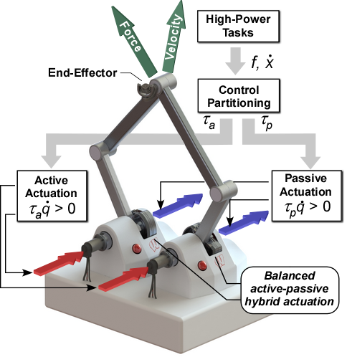

Figure 1: High force, high-power physical interaction using a balanced combination of active and passive actuation.

The objectives of this proposal include the investigation of balanced active-passive hybrid actuation for high-power physically interactive human-robot applications, and its assessment in the context of lower limb robotic rehabilitation. The research will seek to gain insight into the fundamental characteristics, trade-offs, and techniques for optimal application of active-passive hybrid actuation. These insights will be gained through modeling of the complex design space of sensors and actuators, investigation of design techniques to minimize performance limitations, and development of control and estimation approaches to extend performance, safety, and rendering capabilities. This approach to actuation for physical human-machine interaction will be assessed and validated through the development of a high-performance two degree-of-freedom robot for studying and training lower-limb motor control.

# Background

As described above, the objectives of this proposal include the investigation of balanced active-passive hybrid actuation for high-power, physically interactive human-robot applications and its evaluation and validation via the prototypical example of lower-limb rehabilitation robotics. To motivate the proposed research plan and provide context, the sections below describe relevant background and state-of-the art.

## A Case Study of Inadequate Robotics: Neuromotor Training in the Lower Limb

The human leg is used for much more than rhythmic locomotion. When functioning properly, its tasks include balance and dancing, kicking and dressing, climbing stairs and driving cars and pushing objects. These functions are responsive to both intentional movement choices and external disturbances; they exploit cognitive coordination as well as low-latency responses; they require control of foot position, velocity, and endpoint force, in multiple directions simultaneously. In short, diverse leg functions require control much like that of the arm in reaching and manipulation tasks – capabilities described in a robotics context as manipulability. However, leg rehabilitation after neurological injury focuses heavily on walking, just one of the leg’s many tasks.

Volitional, multidimensional control of the lower limb is rarely a target for intervention. Current rehabilitation is dominated by a few walking-focused approaches, such as: over-ground gait training; body-weight supported [1], split-belt [2], [3] or unilateral [4] treadmill training; and gait training with exoskeletons [5]–[9]. Success has been limited in promoting functional recovery using these techniques [8], [10], [11], and it is rare for improvements in treadmill and robotic training to transfer to free walking [12]. Furthermore, functional gains are often attributable to biomechanical compensation, rather than recovery of volitional muscle control [8], [13], [14].

In contrast, robotic upper-limb reaching therapy provides evidence that properly-structured interventions can produce meaningful gains in flexible motor control [15]–[17]. These interventions are based on a rich body of motor learning research in reaching, in both healthy and impaired persons. Upper-limb robotic therapies promote active user engagement [16] through haptic robotic systems – either exoskeletons that surround the arm, or *manipulanda* (handles) attached to a robot facing the user. These robots use control paradigms such as assistance-as-needed [15], [18], [19], error augmentation [2], [3], [20], [21], adaptive challenge levels [22]–[25], virtual constraints [26], [27], progressive loading [17], [24], and non-intuitive force fields [28]–[30]. In essence, the robot and the user engage in *collaborative rehabilitation*, with the robot providing responsive challenges and the human working to develop the neuromotor control necessary to meet them. A few robotic lower-limb therapies implement related concepts such as movement variability [9], [31], gait-specific force fields [12], [32]–[38], or biofeedback [39], but these approaches are still used within the context of walking. The dichotomy between upper- and lower-limb methods and outcomes suggests that task-specific lower-limb walking therapy may not engage the proper neural circuits in a way that adequately promotes neural plasticity.

It would be valuable to adapt approaches from upper-limb reaching therapy to promote manipulability in the lower limb. However, these approaches require haptic robotic systems to produce novel, therapeutic mechanical environments for the limb by controlling force and motion in multiple directions. Unfortunately, upper-limb robots are not easily adapted to the lower limb, due to its comparatively large workspace and force capacity. Lower-limb exoskeletons could potentially be used, but existing systems are specifically designed to assist upright walking [7], [40]–[43], not to control interaction forces with the user. An alternative is robotic foot-plates, which interact through the feet without attaching to the body. But, existing foot-plate robots again target upright walking [12], [38]. Few leg rehabilitation robots are available commercially [41]–[43], and these lack the workspace and dynamic response characteristics, including high-bandwidth force control, necessary to render haptic leg control tasks.

No existing system is suitable for lower-limb manipulability training, but lower-limb training is a perfect test application for high-performance human-interactive robotic systems. The demands in this application are representative of the challenging, competing use conditions of an ideal collaborative robot. For example, the robot should be low impedance when acted upon by the user (for safety and transparency), while being capable of high impedance position control of a workpiece (when the human’s task requires application of high forces). The robot should be strong enough to move high loads, but also fast enough to keep up with human movement. And, the robot should be able to share mechanical tasks and transfer information to a human through finely-controlled endpoint forces.

## Current Manipulation and Actuation Approaches

While much progress has been made in co-robotics, the overwhelming focus has been on robotic manipulators which have relatively low power capacity, such that the inherent safety risks when working directly with humans are minimized. The focus has been on the design and control of naturally light weight and compliant manipulators [44]–[48]. In this case, human-robot physical interaction and cooperation is enabled via the manipulator’s naturally low output impedance, which both facilitates the control of robot-human physical interaction and limits the total energy transferred during an uncontrolled collision between a robot and a human (the greatest safety risk) [44]. The manipulator’s low output impedance is regulated at low-frequencies through active control [45] and is regulated at high frequencies (i.e. above the active control bandwidth) through the intentional introduction of compliance either in the actuation, drivetrain, manipulator structure, or a combination of these. In essence, the physical characteristics of these manipulators are ideally matched to the requirements of human-robot physical interaction.

Unfortunately, the control and design approach applied to low power systems does not scale to manipulators with high force, power, and bandwidth requirements. Due primarily to the limitations of actuation technology [49], high power manipulators must employ high-reduction transmission designs to achieve the high forces and stiffness required [50]. Such designs are inherently non-back-drivable and possess very high output impedance. These characteristics are in direct opposition to those desired for both human-robot physical interaction and for inherently safe design and operation. As such, virtually all high power robotic manipulators currently in use are installed in isolated or protected areas where human operators are excluded. While this approach guarantees a high level of safety, it prevents any significant human-robot interaction. This has been a major obstacle in the advancement of co-robotics for applications where high power, high force, high stiffness and high bandwidth are necessary.

To enable high-performance robot-human interaction, the high output impedance of high-power manipulators must be reduced to levels sufficient to guarantee inherent safety and to enable human-robot physical interaction without sacrificing the characteristics important in high-performance tasks. Researchers have investigated the use of active force and impedance control [51]–[53], which has been used widely in low-power manipulators. However, in high-power systems, force or impedance control is limited by the manipulator’s lack of self-sensing capability (motor torque measurements cannot be used reliably to estimate contact forces), a capability inherent to low-power co-robotic manipulators. Even when feedback control is used, such as instrumenting the manipulator’s end-effector with a force/torque sensor used in feedback [54], the improved performance is limited to point-to-point interactions at the end effector and is only effective below the feedback control bandwidth.

To simultaneously realize high power and low output impedance, researchers have explored the use of *active compliant actuation*, such as the series elastic actuator [45], [55], [56] or variable stiffness actuators [46], [57], [58]. While active compliant actuation can provide both high force and high power capability, the output torque is only controllable below the closed-loop bandwidth of the elastic actuator, making high frequency torque application – required for rendering high stiffness or inertia – impossible. Efforts to extend the torque bandwidth by augmenting the active elastic actuation with a secondary motor have achieved some success [44], [59], but force and power output remain limited, making these systems insufficient for applications such as lower-limb rehabilitation or manipulation of heavy workpieces, where output power levels can exceed one kilowatt.

More recently, the use of hybrid actuation – the coordinated use of controlled passive actuators in *parallel* with active actuators – has been motivated by its demonstrated advantages including high passive force capacity, low external power requirements, low output impedance when deactivated, improved control robustness, and improved passive force rendering. Interest in hybrid actuation has increased as the advantages of passive actuation have been recognized. Applications include human-interaction systems such as haptic interfaces [60]–[70], exoskeletal rehabilitation systems [71], and prosthetic joints [72]–[75]. Specific hybrid actuation configurations that have been investigated include the use of magneto rheological (MR) brakes in parallel with electric actuators [60]–[64], dual MR brakes coupled through an overrunning clutch (to reduce the negative effects of the MR brake’s nonlinear characteristics) [66]–[68], [76], use of a particle brake in series with an elastic spring and an electric actuator [65] and similar configurations using alternative passive actuators such as eddy-current dampers [70]. While improvements in performance and control robustness have been demonstrated using these approaches, they suffer from one or more significant issues which limit their application, including slow response speed and nonlinear hysteresis associated with the passive actuator [77], and a large mismatch between the active and passive actuators, where the passive torque and (dissipative) power capacity can be an order of magnitude larger than the active capacity [78].

# Research Objectives

To enable human-robot applications that require high force and high power while also maintaining the physical characteristics important for safe and effective interaction we propose a balanced combination of active and passive actuation. The proposed hybrid actuation approach combines energy-absorbing, high-force passive actuation with high-power, low-impedance active compliant actuation (series-elastic actuation). The inclusion of passive actuation helps to minimize power consumption, aid in control stabilization, and provide high-stiffness passive rendering capabilities, while the inclusion of active compliant actuation provides high-force active rendering capabilities and low output impedance. The combined active-passive hybrid will provide equivalent passive and active force and power output. The slow response speeds of both the passive and active compliant actuation and the nonlinear hysteresis of the passive actuator are addressed by including a fast, low-power active actuator in parallel. With this combination of active and passive actuation, we hypothesize that the advantages of high performance active-compliant actuation and high force passive actuation can be realized while mitigating the drawbacks associated with each.

While the application of balanced active-passive hybrid actuation is promising, there are challenges that must be addressed before the method can be applied to lower limb assessment and training, and to high-power physically interactive human-robot interaction applications more generally. Our research objectives seek to address these challenges by investigating three aspects of the problem: modeling and analysis; control and estimation; and evaluation and validation.

# Intellectual Merits and Broader Impacts

## Intellectual Merits

The *intellectual merits* of this work lie in development of a framework for designing and controlling robotic systems based on balanced hybrid active-passive actuation, and theoretical and experimental characterization of their achievable performance. This research will improve the understanding of how active and passive capacities can be balanced to optimize different performance characteristics. These insights will enable new human-collaborative robotic systems that combine high force and power, high bandwidth, and rendering of a wide range of interactive mechanical environments.

## Broader Impacts

If successful, application of the resulting system to lower-limb motor control will enable previously impossible studies and interventions that may ultimately lead to improved rehabilitation strategies for neural or musculoskeletal injury. The work is transformative in its impact on the broad NRI goal of “ubiquitous collaborative robotics,” because it will allow robotic systems to perform better across a wide range of tasks, while ensuring safety in a common workspace with humans. This improvement will be achieved by displaying low active output impedance (for safety in case of contact with humans), but high passive stiffness for precise control of workpiece positioning. Additional *broader impacts* include economic benefits through technology transfer to local and national robotics companies; improved workforce training through integration of new knowledge and technology into educational curricula in robotics and biomechanics; and enhanced participation of underrepresented students through an undergraduate summer research program with a track record of success in recruiting students from underrepresented groups and guiding them to graduate programs.

# Research Team

Peter Adamczyk (PI, UW-Madison) joined the faculty at UW-Madison in 2015 and has studied lower limb mobility, impairments and rehabilitation using semi-active robotic systems. Prior to joining UW-Madison, he was the managing member of Intelligent Prosthetic Systems, LLC, a startup company dedicated to developing wearable mobility assessment systems and semi-active robotic lower-limb prostheses. *Dr. Adamczyk’s expertise is in locomotion neuromechanics, dynamical systems analysis, biomechatronic systems design, rehabilitation engineering, and wearable sensors.*

Michael Zinn (Co-PI, UW-Madison) joined the faculty at UW-Madison in 2007 and has been extensively involved in studying advanced robotic actuation systems and their associated control laws, including design and control of surgical catheter systems. Prior to joining UW-Madison, he served as Director of Systems and Controls Engineering at Hansen Medical where he helped develop the world’s first commercially available minimally invasive flexible surgical robotic system. He has researched several areas related to this project, including hybrid actuators *Dr. Zinn’s expertise is in hybrid actuation systems, including active/passive hybrids as proposed for this project, continuum/rigid hybrid catheters, and macro/mini hybrid haptic devices.*

Kreg Gruben (Co-PI, UW-Madison) joined UW-Madison in 1994 and has studied normal and stroke-impaired control of lower limb forces and balance. He has used robotic systems extensively to probe the human motor control system and apply novel rehabilitative environments. Dr. Gruben is owner of KIINCE, a UW-Madison spin-out that makes an advanced robotic rehabilitation system based on promoting proper directional foot force control during walking and standing. *Dr. Gruben’s expertise is in human biomechanics, motor control, stroke rehabilitation, and robotic systems design.*

# Research Plan

The research plan seeks to address the challenges of realizing high-force, high-power physically interactive human-robot interaction with balanced active-passive hybrid actuation through a multi-disciplinary approach partitioned into three major research thrusts: modeling and analysis, control and estimation, and evaluation and validation in a prototypical application.

## Modeling and Analysis

The **Modeling and Analysis** thrust will investigate the analytical modeling of balanced active-passive hybrid actuation to gain insight into its complex design space, to provide tools for control system design and analysis, and to facilitate design optimization regarding performance and safety. To gain a fundamental understanding of the characteristics and dynamics of balanced active-passive hybrid actuation, without the complexity of a multi-degree-of-freedom manipulator, the initial modeling and analysis effort will focus on a simple, one-degree-of-freedom testbed. This testbed system will include: (1) a large-capacity series elastic main motor, to perform high power movements; (2) a controlled brake or damper as a parallel passive actuator, for high-force and stiffness; and (3) a low-power, high-speed motor as a parallel active actuator, to increase the force and movement bandwidth of the system. The modeling and analysis investigation will seek to: (1) develop accurate dynamic system models that can be used for both design optimization and control system analysis; and (2) investigate active-passive design optimization, considering electromechanical design elements, and focusing on the options and effects of currently available active and passive actuators.

### Dynamic Systems Modeling

The modeling effort will seek to understand the effects of electro-mechanical design characteristics on performance and safety. Our investigation will especially focus on characteristics of actuators that have been shown to affect the performance and stability in low-power haptic interfaces [59], [79]–[84], where the coupled manipulator-human dynamics are most challenging. These characteristics include drive-train compliance or backlash, sensor quantization, sensor and actuator delay, drive-train friction, and actuator saturation. While a number of performance metrics will be evaluated, rendering performance is the most difficult to quantify. Our investigation will leverage recent results [79], [80] to allow for intuitive evaluation of rendering properties in terms of an equivalent mass-spring-damper system, providing a direct comparison to the intended rendering impedance. Stability will be assessed using several approaches including transform techniques (e.g. Nyquist criteria) or passivity-based methods [85].



Figure 2: Low order lumped parameter modeling (example) of a single degree-of-freedom manipulator based on balanced active-passive hybrid actuation.

It is also critical to gain an understanding of the complex nonlinear dynamics of multi-degree-of-freedom hybrid actuation and manipulation, considering the interaction and coupling of the parallel active and passive actuation with the manipulator, dynamic interactions with the environment (e.g. human user) and the non-isotropic nature of task-space force and power requirements and their nonlinear mapping to the active and passive joint space actuators.

Similar to the approach taken in [82], a lumped parameter mass-spring-damper abstraction will be used to model the system behavior, including coupled dynamics of the robot and the human operator. One advantage of using compliant, low-impedance actuation, such as the main series elastic actuator, is that the dynamic models used to describe them can be tuned to a high degree of accuracy. The low stiffness compliance, purposely placed in the drive train, results in a fundamental vibration mode with very low frequency relative to other structural resonances with much higher frequency. As a result, low-order lumped parameter models can be developed to capture the low frequency fundamental mode dynamics very accurately while ignoring the less relevant and more complex higher modes (see Figure 2).

### Passive Actuation Modeling

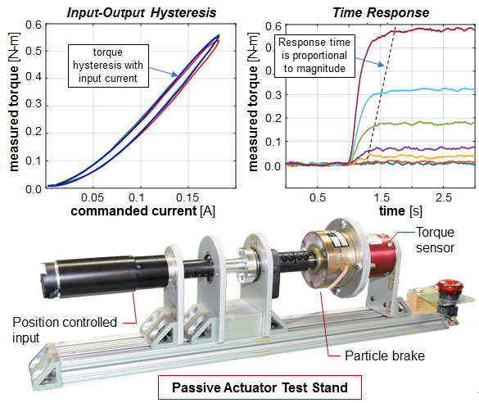

Figure 3: Passive actuator (particle brake) test stand and preliminary data. Nonlinear input-output hysteresis and variable time response will be quantified for candidate passive actuators in the proposed work.

The active actuation and manipulator dynamics can be modeled with a high degree of accuracy, but the controlled passive actuators exhibit nonlinear characteristics which are not well understood. This research will focus especially on gaining a robust understanding of these features. Several researches have reported that passive actuators, including particle and MR brakes, exhibit output torque hysteresis relative to input excitation (e.g. input drive current) and possess slow transient response characteristics (as compared to electromagnetic actuation) [68], [86]. Basic dynamic system models have been proposed [77], but these models are too simple and do not capture the actuator’s dynamics with enough detail to be useful in more advanced control and estimation approaches. Recent experimental work performed by Co-PI Zinn’s group has uncovered additional nonlinear dynamic characteristics that are relevant in developing effective closed-loop controllers, including nonlinear transient response and position dependent behavior (see Figure 3).

The investigation of passive actuator modeling will seek to uncover all relevant nonlinear characteristics including slow nonlinear transient response, nonlinear input-current-to-torque relationships, and nonlinear hysteresis relative to both input current and output velocity. The objective of the modeling effort is to develop analytical models with sufficient accuracy to support electromechanical and control system analysis and design. Toward this, the modeling investigation will seek to establish a connection between observed performance and the underlying physics of the passive device. This approach will also allow extension to other devices using similar physical principles.

The investigation will consider a range of passive actuator options including particle brakes, hysteresis brakes, MR brakes, and friction-plate brakes. The set of passive actuators to be investigated broadly covers those previously proposed for robotic applications. Each has advantages and disadvantages that are derived from the underlying physics that govern their operation. For example, particle brakes contain ferromagnetic particles encased in the brake housing, through which the rotor moves. The application of current to the brake windings results in a magnetic flux which causes the brake particles to bind together, providing resistance to the motion of the rotor which is proportional to current. The interaction of the particles with the induced flux field and the brake’s mechanical housing and rotor results in complex nonlinear characteristics that are a function of both time and rotation. The other brake options to be considered have similarly complex torque characteristics.

### Modeling – Experimental Investigation

The dynamic system modeling effort will be supported and validated using a one degree-of-freedom hybrid actuation testbed that has recently been developed in Co-PI Zinn’s laboratory [87]. The hybrid actuation testbed includes an active compliant actuator (series elastic actuator and small servo motor), a passive actuator interface, and a host of instrumentation (Figure 4) to support system identification efforts. The testbed is designed to investigate a range of passive actuator options including particle brakes, hysteresis brakes, MR brakes, and friction-plate brakes. Separately, a passive actuator characterization platform (see Figure 3) has been developed to experimentally investigate passive actuator dynamic system characteristics at a detailed level.

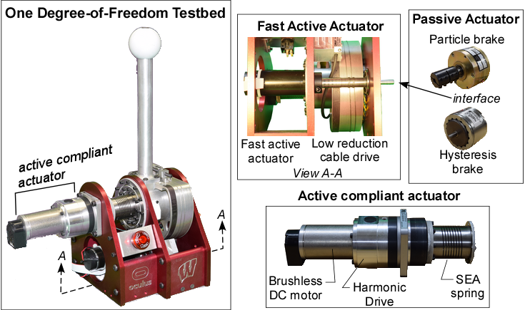

Figure 4: Architecture of the balanced hybrid active-passive actuator system. A high-power active compliant actuator, a high-force controlled passive actuator, and a low-power fast active actuator all act in parallel, allowing the strengths of each to compensate for the weaknesses of the others.

The experimental investigation will seek to inform and validate the one degree-of-freedom modeling effort through the measurement of device input, state, and output variables. Using time and frequency domain system identification techniques, the dynamic response of the testbed will be measured and compared to the analytical models developed above. The experimental investigation will focus on identifying relevant dynamic system elements which may have been overlooked in the modeling effort. These might include structural or drive-train resonances below the bandwidth of the closed-loop controller, or significant frictional losses, for example. The passive actuator characterization platform will provide measurement of passive actuator torque response as a function of input current, rotation, velocity, and load, allowing for experimental development and validation of detailed passive actuator dynamic models.

## Control and Estimation

The methods chosen for control and estimation will have a significant effect on the performance and safety of high-force, high-power cooperative robotic systems based on a balanced active-passive hybrid actuation approach. The complex system dynamics, consisting of coupled and redundant actuation, nonlinear passive actuation dynamics, and coupled robot-human dynamics will require careful consideration in order to develop effective and robust control techniques.

### Active-Passive Control Partitioning

Hybrid actuation is, by nature, a redundant approach. At each robot joint, active and passive torques act in parallel, creating a torque partitioning problem: how much torque should each actuator produce? This problem is exacerbated by the differing nonlinear characteristics and dynamic response of the different actuators. The problem requires control optimization techniques to balance multiple actuators to achieve high performance and robust stability. In a multi-joint manipulator, redundancy increases further in proportion to the number of joints. Task-space forces and moments (from human or workpiece interaction) can be mapped to joint torques in the usual way (through manipulator kinematics and dynamics), but the torque partitioning problem remains at each joint. As a result, passive and active task-space forces do not map uniquely to passive and active torques at each joint. Instead, the redundant, coupled, and nonlinear system requires control optimization strategies to balance multiple actuators to achieve high performance and robust stability. Several control approaches will be considered.

Use of linear optimal control (specifically the linear quadratic regulator (LQR)), will serve as the baseline to which other control approaches are compared. LQR control can be effective for multi-input systems through proper design of weighting matrices. The input weighting matrix can be adjusted to partition the torques into high and low power components. In this case, the input weighting matrix is adjusted to favor use of the high-power input, corresponding to the sum of the series elastic actuator and passive actuator torques, while limiting the use of the low power input, corresponding to the small, fast servo motor. The resulting high-power input is then further partitioned into active and passive torque commands, provided by the series elastic and passive actuators, respectively. The advantages of LQR include its relative simplicity and the ability to design the controller using a wide range of input and output weighting, providing a large design space from which to optimize performance metrics. Disadvantages include its difficulty with nonlinear systems. As such, the passive actuator will require special consideration. Approaches to be considered will include plant model inversion (feedforward control) and active disturbance rejection, discussed in more detail below.

An alternative approach is to partition the control torques in the frequency domain explicitly, prior to their partitioning into passive and active torques (see Figure 5). This approach is appealing due to the frequency characteristics of common manipulation tasks, where the higher forces and power are concentrated at low frequencies. The control investigation will initially consider the use of PQ control [88], where active filtering is used to partition low and high frequency control inputs. The advantages of PQ control include an intuitive tuning process and direct control over the division of low- and high-frequency content. The investigation will focus on its extension to multi-degree-of-freedom systems in the presence of actuator nonlinearities, an area not previously considered.

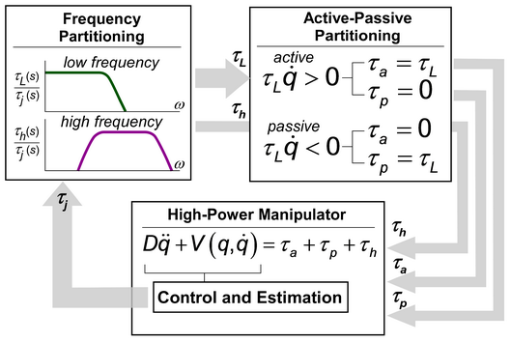

Figure 5: Candidate control/actuation partitioning approach. Total joint moment (*τ*j) from the robot controller is partitioned into low-frequency (*τ*L) and high-frequency (*τ*h) components. Low-frequency components are further partitioned into active (*τ*a) and passive (*τ*p) components. *τ*a, *τ*p and *τ*h are then commanded to the active-compliant, controlled passive and fast-active actuators, respectively.

Another alternative for torque partitioning, suggested in [44], partitions the control torques using the natural dynamics of the actuators. The control structure is very intuitive and naturally respects the actuator frequency domain constraints but has difficulty in the presence of drive-train nonlinearities such as actuator saturation and backlash [89]. Our investigation will explore its application to nonlinear actuation and seek to improve its robustness in the presence of nonlinearities, of concern in hybrid actuation.

### Active-Passive Estimation

Perhaps the greatest control challenge is the integration of the passive and active actuators such that torque production is predictable and controllable. To effectively control a complex dynamic system, it is essential to have precise knowledge of internal and external signals which affect its behavior. These include internal system states such as joint and actuator positions and velocities, model physical parameters, and disturbances including unmodeled frictional and human-robot interaction forces. The nonlinear characteristics of the passive actuator, including its slow response time and nonlinear frictional characteristics, present significant challenges. As such, it will be essential to obtain good estimates of both passive actuator output torque and passive actuator model state and parameter information.

Toward this end, we will investigate the use of nonlinear dynamic system observers. Here, the approach is to compare the response of the modeled system dynamics to that of the measured system outputs (e.g. manipulator positions and velocities, end-effector forces). The difference between the measured outputs and the model’s predicted outputs is used, via feedback, to guide the model’s output to track the response of the measured system. As the modeled system converges to the measured system’s output, the model’s internal states track the internal states and disturbances of the real system. The challenge is to develop measurement and feedback laws to drive this convergence.

A candidate observer structure, designed to estimate both the passive actuator’s output torque and its internal nonlinear model parameters, is shown in Figure 6. We will investigate the use of a *disturbance observer* structure [85] to estimate the output torque of the passive actuator, which is difficult to measure directly. In this case, the system dynamics model is augmented with a simplified disturbance dynamics model, representing a locally linearized version of the passive actuator’s dynamics. The observer will provide estimates of the manipulator states (joint positions and velocities), active actuation states (position, speed and torque of the motors), and the simplified disturbance model states, which in turn are used to estimate the passive actuator’s output torque. The passive actuator’s model parameters may be estimated using a nonlinear observer structure, based on the passive actuator’s full dynamics model, cascaded with the passive actuator output torque signal as seen in Figure 6. The combined torque and parameter observers will provide estimates of passive actuator torque output, internal states (e.g. magnetic field, viscoelastic wind-up, etc.), and time varying parameter values, all of which may be useful in the controller design.

We will explore various observer designs regarding the choice of passive actuator dynamic models, with the goal of balancing complexity, model execution time, and accuracy. We will investigate the benefits of incorporating additional measurements to improve observer performance and robustness. Optional measurements include the use of external signals, such as end-effector force and torque measurements and internal signals, such as series elastic actuator spring deflections. Methods to optimally estimate states using multiple sensor sources in combination with nonlinear models, such as an extended Kalman filter, will be explored. Finally, we will explore the extension of the proposed observer approach to provide estimates of human interaction forces, both intentional (through the end-effector) and unintentional (through unmeasured contact with other parts of the manipulator).

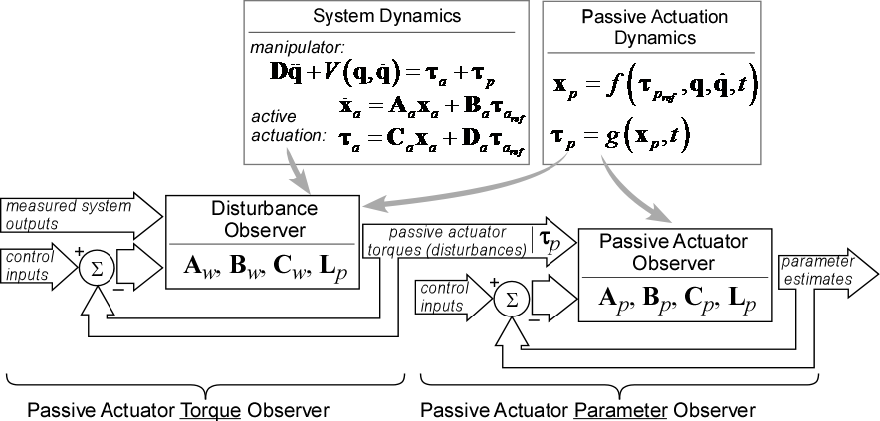

Figure 6: A passive actuator observer will be used to estimate passive actuator output torque and internal states. These states and outputs will be used in control implementation across all three actuator components in the combined system.

### Performance Enhancement through Advanced Control

Performance of the actuation and manipulator control may be significantly improved through active compensation of non-ideal passive actuator torque. We will investigate a variety of control approaches, leveraging the benefits of the estimation investigation described above. Options to be considered initially will include the use of plant model inversion and active disturbance rejection.

With plant model inversion, a linearized version of the nonlinear passive actuator model is used to evaluate feedforward inputs to reduce or eliminate the negative effects of non-ideal passive actuator torque. The approach is essentially open-loop and relies on the availability of an accurate system model, thus emphasizing the need for both high fidelity modeling and robust observer design. Nonlinear characteristics associated with the passive actuator, such as input-output hysteresis and nonlinear torque-current relationship, can be significantly reduced using feedforward control.

As described, plant model inversion is an open-loop approach and thus cannot compensate for unmodeled system dynamics or disturbances. If these dynamics and disturbances remain problematic, we will investigate a control approach that actively cancels unwanted passive actuator torque components. Using the estimated torque signal from the passive actuator torque observer, unwanted components can be isolated and removed using active actuation control. Large, low frequency disturbances can be compensated using the high-power active actuator while high-frequency disturbances can be canceled using the fast, active actuator.

The result of these advanced methods for modeling, estimation and control will be a robotic system that exceeds the performance currently achievable through established design and control approaches. The robot will possess the best characteristics of both active and passive actuation. In particular, it will be able to exhibit both high and low impedance on demand, with high force and power capacity, while also retaining high force-control bandwidth. These improvements will be quantified and applied to the problem of human lower-limb motor training, to validate their benefits in human-robot collaboration.

### Control for Safety

In cooperative human-robot manipulation, safety is of paramount concern. Our use of balanced active-passive hybrid actuation is largely motivated by its superior safety characteristics. Unlike existing high-power and high-force manipulators which are generally non-backdrivable and possess very high output impedance, active-passive hybrid actuation has naturally low output impedance. Within the closed-loop bandwidth of the compliant actuation, the output impedance is approximately equal to the effective inertia of the manipulator linkage, decoupled from the high reflected inertia of the high-power active actuator. Above the closed-loop bandwidth, the output impedance is equal to the manipulator’s effective inertia in series with the compliant actuator’s spring stiffness. In either case, the risk of injury due to an uncontrolled collision [90] is directly related to the amount of effective inertia or effective kinetic energy, more generally, at the contact point. With proper mechanical and control design, the effective kinetic energy can be minimized. Specific design choices include locating the heavy, high-power actuators at the base of the manipulator and designing the structure from light, high-stiffness composites, both of which reduce the effective inertia. Additionally, the manipulator’s maximum task-space velocity can be limited.

While a manipulator powered through hybrid actuation is much less dangerous than existing high-power manipulators, the high-power tasks under consideration do present safety challenges that must be addressed. As a first step, we will leverage techniques developed in safety-critical industries, including the use of sensor and communication redundancy and real-time fault detection and mitigation. *Co-PI Zinn has extensive industrial experience developing safety critical surgical robotic systems, including those whose malfunction could be life-threating.*

A unique characteristic of low-impedance actuation is its ability to sense applied forces and torques, an ability referred to as self-sensing. In the case of active-passive hybrid actuation, self-sensing is enabled through the measurement of the compliant actuator’s spring deflection, monitoring of passive actuator torques (which react passively to unwanted motion), and monitoring of joint motions. We will investigate use of the manipulator’s self-sensing characteristics to detect unwanted collisions in real-time. A simple initial approach will be to monitor and compare measured actuation torque to commanded torque. In addition, more robust estimation strategies will be investigated including use of a disturbance observer structure similar to the one described in Section 6.2.2. In this case, the disturbance observer would consider measured actuator torques, joint motions, and other available information (e.g. end-effector force-torque sensor) along with use of a manipulator dynamic model. This structure will result in a more robust detection and estimation of contact forces. Regarding collision mitigation, we will investigate the use of the passive actuators to quickly dissipate the manipulator’s effective kinetic energy. Active actuator kinetic energy can be dissipated through the use of actuator safety brakes (on-off). Fortunately, the compliant actuator’s soft spring allows time for collision detection and mitigation before the active actuator’s high effective kinetic energy can pose a danger, a characteristic lacking in existing high-power manipulators.

### Control – Experimental Investigation

The control investigation will be supported and validated using the one degree-of-freedom hybrid actuation testbed developed in in Co-PI Zinn’s laboratory [87] (see Figure 3). The testbed will support direct measurement of the device’s output impedance as a function of frequency, assessment of stable operating regimes (e.g. with respect to rendering stiffness), and performance verification more generally. In addition, the testbed mechanical design and controller allows for the purposeful introduction of several non-ideal characteristics, including drive-train compliance and backlash, and, through emulation, sensor quantization, communication delay, and actuator saturation. This capability will provide a means to assess performance, control robustness, and model accuracy as a function of non-ideal and nonlinear design characteristics.

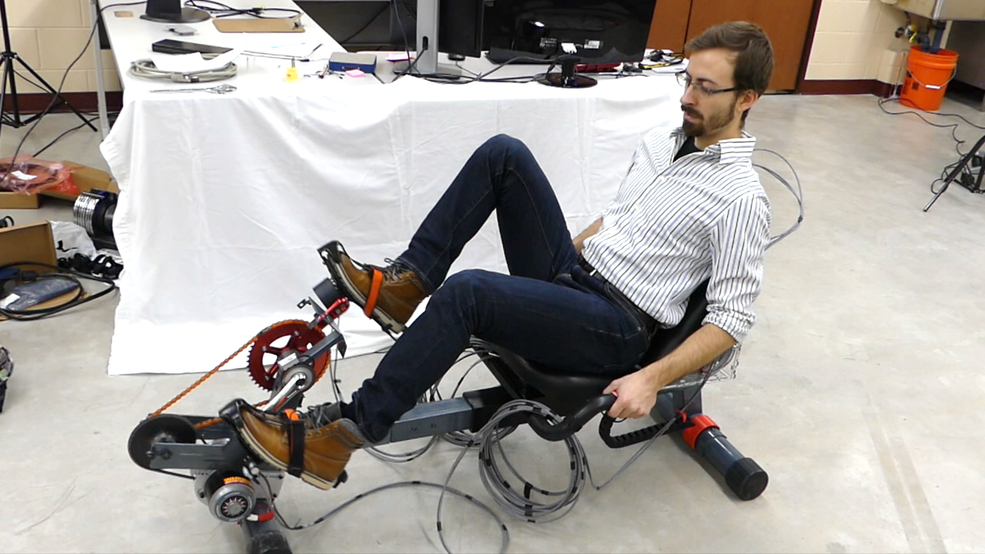

Figure 7: Custom-built one-degree-of-freedom robotic cycle for will be used to characterize the force capacity of human subjects in multiple directions and multiple postures. These data will be used to specify the required capacity of the two-degree-of-freedom planar manipulator proposed in the present project.

## Multi-Degree-of-Freedom Manipulation

To demonstrate that our approach is effective, we must consider its extension to multi-degree-of-freedom manipulation. As such, we propose the development of a two-degree-of-freedom prototype that will allow for the validation of modeling extensions and the investigation of various control and estimation approaches for general high-power active-passive hybrid actuated manipulation. To provide specific application context to our evaluation, the prototype will be developed to perform in a prototypical human-interaction case: lower-limb manipulability training. A two degree-of-freedom manipulator designed for this scenario will provide a valuable platform for evaluating the performance and limitations of hybrid active-passive actuation for general high-power, human interactive applications. The robot will be designed as a general-purpose planar manipulator, with specifications reflecting the workspace and force-production capabilities of the human lower-limb.

### Goals and Specifications

The main task for this robot is to render arbitrary planar force fields such as those commonly used for motor assessment and training in the upper limb [29], [91] (also see Figure 10). The application demands high performance and careful design, because the leg can produce very high forces during whole-leg extension and flexion movements, which the robot must be able to support while still moving quickly in multiple dimensions under precise control. Additionally, the system requires the ability to maintain high-impedance positioning for trials measuring volitional force regulation throughout the leg’s workspace. And, because the human leg has a three-dimensional workspace, the robot must allow use in all three anatomical planes (see Figure 9).

To ensure that the design specifications are correct, we will experimentally evaluate critical requirements using an existing instrumented robotic bicycle (Figure 7). We will estimate maximum task-space force and velocity requirements as a function of position, and quantify seated range of motion to define the robot’s workspace. We will program the cycle to hold various pedal positions, and test subjects will exert brief (2-3 second) maximal forces along each axis of the pedal (extension/retraction, anterior/posterior, medial/lateral). Because the pedal positions span much of the sagittal workspace, the maximum measured forces will be used as representative performance specifications for the robot’s load capacity. For range of motion, a motion capture system will be used to quantify foot movement while the subject moves his leg through its range of motion. Limits will be defined by the maximal reach of the foot in each dimension. All specifications will be validated by comparison to related values in the literature.

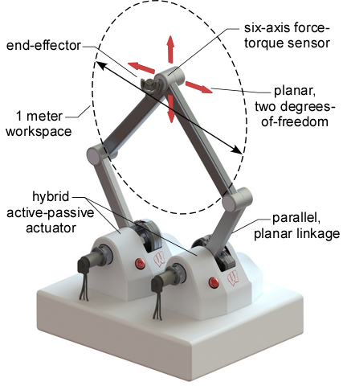

Figure 8: Initial concept for the two degree-of-freedom robotic testbed. Two balanced active-passive hybrid actuators control a parallel linkage with workspace and force capacity appropriate for the human leg.

### Planar Robotic Testbed

While the final design may be altered based on results from the one degree-of-freedom testbed, an initial concept for the two degree-of-freedom robotic testbed is shown in Figure 8. The manipulator prototype will have a planar, parallel linkage structure, with the hybrid active-passive actuator located at the base of the manipulator (grounded). This structure simplifies the drive train design compared to a serial linkage, reduces manipulator inertia, and ensures that the largest task-space passive forces map to passive joint torques. Each base joint will be actuated with a prototype active-passive hybrid actuator designed according to the findings of the one degree-of-freedom testbed. Similar to the one degree-of-freedom testbed, the planar two degree-of-freedom system will be instrumented to capture relevant input, output, and state information and will additionally include a six-axis force-torque sensor at the endpoint, to provide direct measurement of interaction forces and moments. To support the prototypical human-interaction case of lower-limb manipulability training, the robot will be designed to span the workspace of the human leg in each plane (Table 1) and will be designed to support the specified design loads in all directions, allowing for use in general applications where out-of-plane constraint forces may be comparable with task-space forces.

Table 1: Specifications for a two degree-of-freedom planar manipulator

|  |  |  |  |  |
| --- | --- | --- | --- | --- |
| Direction | Total Forcea | Active Forceb | Workspacec | No-load  Speedd |
| Axial (*x*) | 1000 N | 500 N | 1 m | 3 m/s |
| Transverse (*y*) | 300 N | 150 N | 1 m | 6 m/s |
| Out-of-plane (*z*) | 1000 N | - | - | - |

a. Total force capacity estimated as 1.25 (*x*), or 0.30 (*y*) times body weight, based on leg forces of an 80 kg person walking at 2.0 m/s. Out-of-plane structures (*z*) must support the maximum of any load.

b. Active force is half of total force, reflecting isolated active actuation (motors).

c. Workspace estimated from approx. foot excursions of a 2 m tall male.

d. Speed estimated from a foot-lifting experiment (*x*) and from walking at 2.0 m/s (*y*).

### Extension and Validation of Modeling and Control Approach

It is essential that we assess the effectiveness of our modeling approach and assess the performance, stability, and robustness of the control approach when extended to a multi-degree-of-freedom system. Characteristics not present in a one degree-of-freedom system include the complex nonlinear dynamics of multi-degree-of-freedom hybrid actuation and manipulation, considering the interaction and coupling of the parallel active and passive actuation with the manipulator, and dynamic interactions with the environment (e.g. human user). Additionally, the coupled manipulator kinematics will result in a nonlinear mapping of task-space active and passive forces to joint-space active and passive torques, possibly affecting the frequency and active/passive control torque partitioning approaches discussed in Section 6.2.1 (see also Figure 5).

Using the two degree-of-freedom planar testbed, we will investigate how to extend the control and estimation approaches of Section 6.2.2-6.2.3 to a multi-degree-of-freedom context, accounting for the coupled kinematics and dynamics of the two degree-of-freedom device. We will experimentally evaluate the control and estimation methods for their effects on stability and rendering performance. Additionally, we will evaluate the system’s ability to produce the performance specifications determined for our prototypical application of lower limb manipulability training.

Stability and rendering performance will be evaluated experimentally using frequency domain techniques. Due to the low impedance characteristics of the manipulator and actuation design, output impedance, from which rendering performance is assessed, can be measured by driving the manipulator end-point using an external input, in this case a linear positioning system. End effector movements, forces and moments are measured, and output impedance characteristics are derived from these measurements. Using a similar experimental approach, we will evaluate the range of physical impedances that can be stably rendered, as described by the parameter values of an equivalent mass-spring-damper system. These experimental metrics will provide direct assessment of haptic performance. Finally, we will characterize the testbed’s general performance through a set of benchtop experiments. We will measure the achievable workspace, force, and power output, as well as performance in dynamic position and force control, as measured by bandwidth and disturbance rejection characteristics.

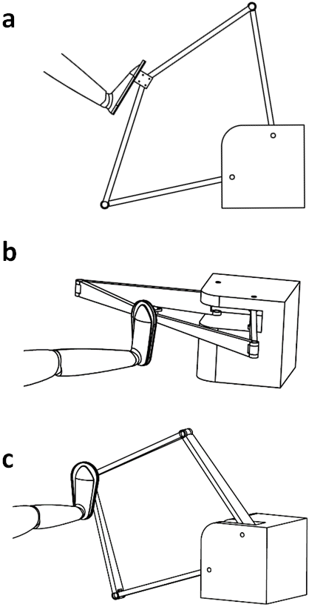

Figure 9: The two-degree-of-freedom manipulator will be designed to operate in all three anatomical planes with minor reconfiguration: (a) sagittal, (b) frontal, and (c) transverse plane configurations.

## Validation of Utility for Human Motor Training

The planar two degree-of-freedom testbed described above will be used in human motor training experiments to validate its performance in an application specific example. In support of this, the testbed will be modified to support lower-limb motor control experiments.

The user will sit in a fixed seat facing the robot, and one foot will be strapped to a pedal constituting the robot’s end effector. The robot enclosure and actuators will be designed to allow mounting in any of the anatomical planes (sagittal, frontal, transverse), to control motion and force fields in any combination of two anatomical axes (Figure 9). As described above, the robot will be designed to match the workspace of the human leg in each plane (Section 6.3.1 and Table 1: roughly 1.0 m excursion), and will be programmed to respect the leg’s kinematic limits. The device will be designed to accommodate the specified design loads in all directions.

### Motor Training Effects with the 2-DOF Manipulator

The final step in the proposed research is to validate the robot’s ability to apply arbitrary force fields useful for lower-limb reaching training, and pilot test the effects of these fields on motor learning. The subject will sit with the foot (attached to the robot’s end effector) in a central position, and move to a target in a specific location indicated on a computer screen (Figure 10, Right). We will investigate path straightness, speed, and other aspects of performance while force fields of interest in motor training paradigms are applied.

First, we will program a “viscous curl” force field [21], [29], [91], in which forces are applied to perturb the limb’s movement away from a straight path. The forces are computed from the two-dimensional endpoint velocity $\left(\begin{matrix}\dot{x} & \dot{y}\end{matrix}\right)$ by a matrix that couples the *x* and *y* directions. Two potential examples are shown in Figure 10 (Left, Center) [21], [91]. These fields produce forces that push the end effector away from straight paths, creating a disturbance that participants learn to reject. Adaptation to such fields, and the *aftereffects* when the field is removed in *catch trials*, are classic results demonstrating learning of an internal model of the force field. We expect to observe both phenomena, which have not previously been shown in lower limb reaching.

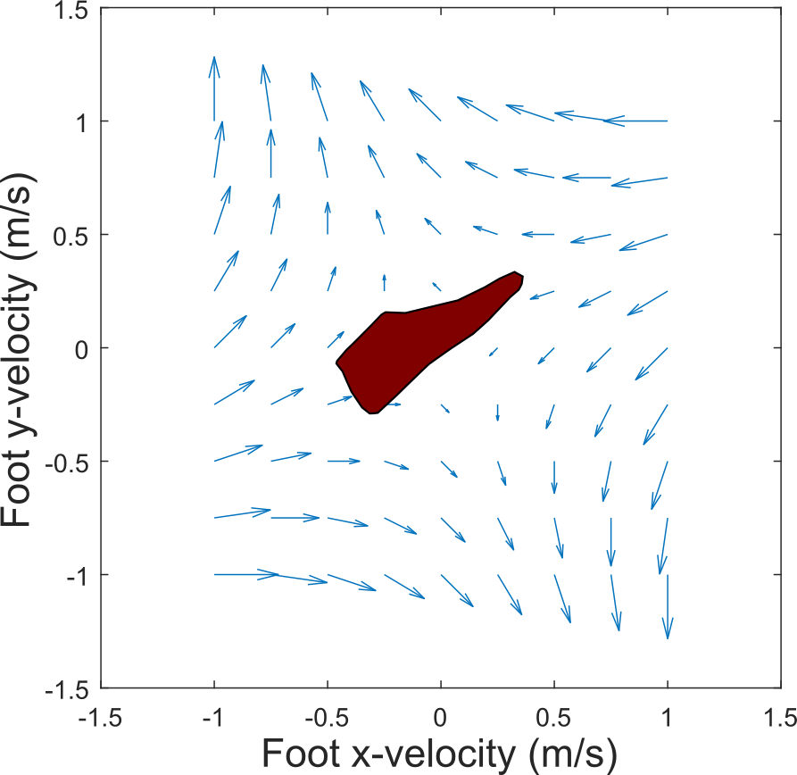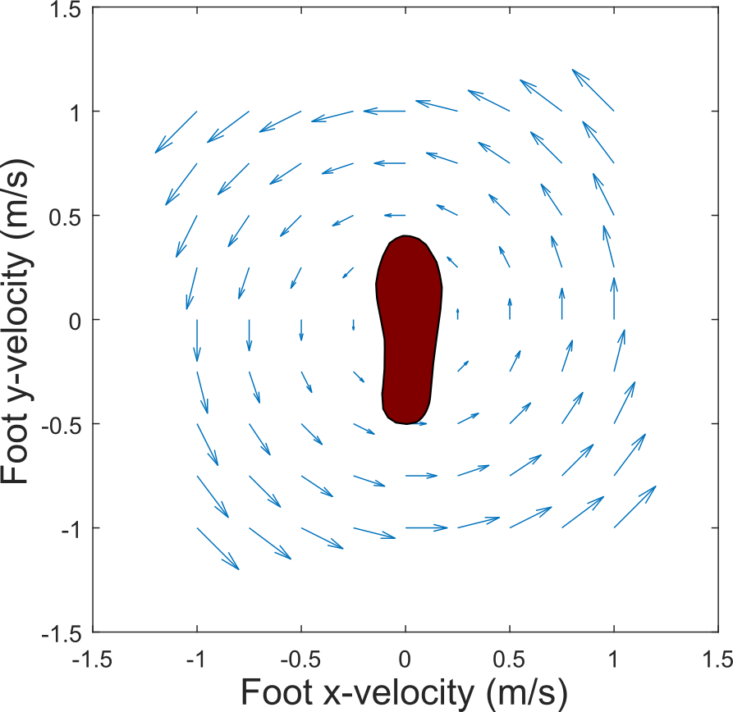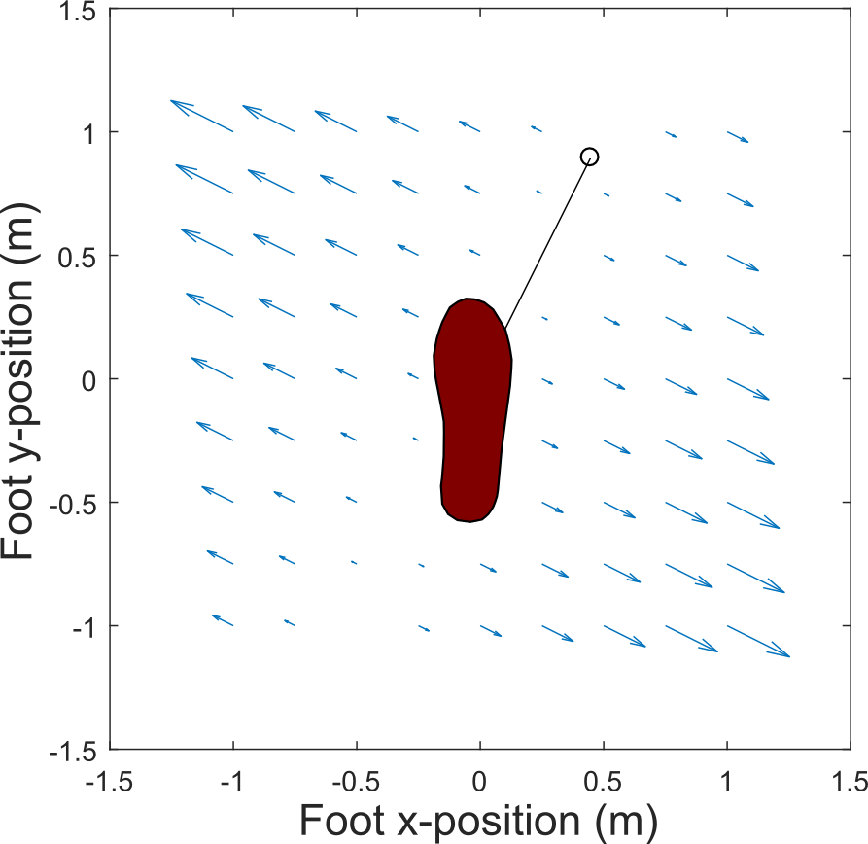

Figure 10: Example force field candidates for lower-limb motor control studies. The subject reaches one foot toward a target (see right frame) while the robot applies disturbance forces (arrows). Left and center: two versions of "viscous curl", in which force applied to the foot is computed from foot velocity. Right: error augmentation field, in which force is proportional to the vector error from a straight-line path to the target. These approaches are used to demonstrate and drive motor learning in the upper limb, but have not been used for the lower limb.

Foot outlines not drawn to scale.

Second, we will program an error augmentation force field (Figure 10, Right), in which destabilizing forces are applied in proportion to the vector deviation from an ideal straight line toward the target point. In general, practice in error augmentation fields causes users to produce straighter paths (reduced deviation) as training progresses [21], and we expect to observe this trend as well.

### Evaluation of Stability and Utility

Viscous curl and error augmentation, where the applied force is a function of the user input motion (velocity or position), are challenging haptic effects to render, and can be used to evaluate the performance and stability limits of the planar two degree-of-freedom testbed in the context of lower-limb motor training. For example, performance in rendering viscous curl can be defined by the two-dimensional space of possible curl fields where the system is stable, parameterized by a principle and coupled damping coefficient. This approach is similar to the commonly used z-width [77], [90], where the performance of a haptic interface is defined by the space of stiffness and damping the interface is capable of rendering stably. To evaluate performance in viscous curl, we will perform a pilot test of many variations of curl fields, and experimentally determine the stable space of haptic curls. The results will be compared to published results for comparable, albeit less powerful, upper-limb rehabilitation devices and desktop haptic interfaces. A similar approach can be used for other fields such as error augmentation, virtual springs and virtual masses.

If these pilot results are as expected, the concept of using haptic force fields and lower-limb reaching tasks will be proven feasible. In this case, the Investigators will pursue further studies of motor control and motor learning using these and other novel mechanical environments, in healthy and impaired individuals. Such environments may include: patient-specific force fields [28]; cross-axis force coupling; emulations of arbitrary impedances including negative mass, stiffness or damping; virtual constraints among joints [26], [27]; progressive loading to promote independent joint control [17], [24]; and others. Future robots to accomplish these goals may also add a third robotic degree of freedom according to the principles elucidated in this research. The long-term goal is to improve functional restoration after neural or musculoskeletal injury by employing collaborative human-robot rehabilitation methods that guide neural adaptation toward recovery of flexible, volitional foot control.

# Education and Outreach Activities

This research will integrate into a number of educational and outreach activities the investigators already support. Foremost among these is the direct involvement of graduate and undergraduate students in the research project. Graduate education is the core educational mission, and this project will fund the involvement of multiple graduate students. We also plan to involve undergraduate students through the UW-Madison SURE program, a summer research opportunity for students from underrepresented groups, which has proven successful in promoting successful graduate study. For outreach, we plan to use the one-degree-of-freedom (DOF) system to demonstrate human-interactive robotics during the Engineering Expo and National Biomechanics Day showcase, held each April. The UW-Madison Biomechanics group (consisting of several labs including those of Drs. Adamczyk and Zinn) has won two consecutive awards for having the best demonstration room on campus, and won the Impact Award for reaching the most students (roughly 2000) for National Biomechanics Day 2017. The project also fits into additional outreach programs that project personnel are regularly involved in, including the summertime PEOPLE program for high school students from groups underrepresented in college, and the RescuShell pre-engineering virtual internship for underserved high school students. Finally, the investigators plan to apply for an REU once the project is funded, to involve additional undergraduate students in the research. This REU will target underrepresented minorities by cooperating with the UW-Madison SURE program for recruitment. SURE is an engineering-focused summer research program for students from underrepresented groups, with demonstrated success in promoting graduate study among participants.

# Project Management and Timeline

Dr. Adamczyk will oversee the overall project to ensure the technical development addresses the objectives in modeling, design, control, evaluation, and validation. Dr. Zinn will lead the robotic investigation, and Drs. Adamczyk and Gruben will collaborate with him on the haptic evaluation and interpretation. Drs. Adamczyk and Gruben will lead the motor training validation studies. The research plan will be carried out over a three year time span, with two coupled branches of development: (a) robotics development, and (b) human-interaction design. Year 1 robotics development will focus on modeling, analysis and control of a 1-DOF robot based on active-passive hybrid actuation. These efforts will solidify the analytical framework needed to complete a multiple-DOF system. In parallel, Year 1 efforts to characterize the required human interaction will focus on determining the force, speed and power capacity of the human in multiple directions throughout the lower-limb workspace. Year 2 robotics development will apply the new technical tools to create a 2-DOF planar robot capable of the force, speed, power, bandwidth, and workspace defined by the human characterization. In parallel, Year 2 human-interaction design will focus on implementing haptic environments in the 1-DOF robot, and defining and preparing haptic control laws for the 2-DOF robot under construction. Year 3 robotics development will evaluate the performance of the 2-DOF system according to the specifications it was built to achieve. In parallel, Year 3 human-interaction design will execute proof-of-concept motor control studies to validate the ability of the 2-DOF system to render haptic environments and produce motor adaptations in leg reaching tasks.

# Results from Most Relevant Prior NSF Support

Michael Zinn is PI of NSF award IIS-1316271 “NRI: Small: Interleaved Continuum-Rigid Manipulation - Enabling High-Performance and Inherent-Safety in Minimally-Invasive Surgical Procedures” ($495,154, 9/1/13 – 8/31/18). *Intellectual Merit*: This award developed a novel approach to minimally invasive surgery (MIS) that combined the inherent safety of soft, continuum manipulators (e.g. catheters) with the accuracy of rigid-link joints. The supported work developed a design and analysis framework and demonstrated increased performance and functionality using a set of novel control strategies [92]–[98]. The research products from this award, including publications cited, conference presentation, and design data are publicly available through the PI’s laboratory website. *Broader Impacts*: The novel MIS approach developed will enable a new class of interventional techniques for neurological, cardiac, and other high-risk procedures. In addition, methods developed for the design and control of hybrid compliant-rigid mechanisms generally will benefit other co-robotic application areas including search and rescue robotics, light manufacturing, and home and healthcare assistive robotics.

# References

[1] J. Mehrholz, M. Pohl, and B. Elsner, “Treadmill training and body weight support for walking after stroke,” *Cochrane Database Syst. Rev.*, vol. 1, p. CD002840, 2014.

[2] D. S. Reisman, H. McLean, J. Keller, K. A. Danks, and A. J. Bastian, “Repeated Split-Belt Treadmill Training Improves Poststroke Step Length Asymmetry,” *Neurorehabil. Neural Repair*, vol. 27, no. 5, pp. 460–468, Jun. 2013.

[3] D. S. Reisman, R. Wityk, K. Silver, and A. J. Bastian, “Locomotor adaptation on a split-belt treadmill can improve walking symmetry post-stroke,” *Brain*, vol. 130, no. 7, pp. 1861–1872, Jul. 2007.

[4] J. H. Kahn and T. G. Hornby, “Rapid and Long-term Adaptations in Gait Symmetry Following Unilateral Step Training in People With Hemiparesis,” *Phys. Ther.*, vol. 89, no. 5, pp. 474–483, May 2009.

[5] M. Alcobendas-Maestro *et al.*, “Lokomat Robotic-Assisted Versus Overground Training Within 3 to 6 Months of Incomplete Spinal Cord Lesion Randomized Controlled Trial,” *Neurorehabil. Neural Repair*, vol. 26, no. 9, pp. 1058–1063, Nov. 2012.

[6] J. Hidler *et al.*, “Multicenter Randomized Clinical Trial Evaluating the Effectiveness of the Lokomat in Subacute Stroke,” *Neurorehabil. Neural Repair*, vol. 23, no. 1, pp. 5–13, Jan. 2009.

[7] C. Bonnyaud, D. Pradon, J. Boudarham, J. Robertson, N. Vuillerme, and N. Roche, “Effects of Gait Training Using a Robotic Constraint (Lokomat®) on Gait Kinematics and Kinetics in Chronic Stroke Patients,” *J. Rehabil. Med.*, vol. 46, no. 2, pp. 132–138, Feb. 2014.

[8] P. Langhorne, J. Bernhardt, and G. Kwakkel, “Stroke rehabilitation,” *Lancet Lond. Engl.*, vol. 377, no. 9778, pp. 1693–1702, May 2011.

[9] M. D. Lewek, T. H. Cruz, J. L. Moore, H. R. Roth, Y. Y. Dhaher, and T. G. Hornby, “Allowing Intralimb Kinematic Variability During Locomotor Training Poststroke Improves Kinematic Consistency: A Subgroup Analysis From a Randomized Clinical Trial,” *Phys. Ther.*, vol. 89, no. 8, pp. 829–839, Aug. 2009.

[10] P. Langhorne, F. Coupar, and A. Pollock, “Motor recovery after stroke: a systematic review,” *Lancet Neurol.*, vol. 8, no. 8, pp. 741–754, 2009.

[11] D. R. Louie and J. J. Eng, “Powered robotic exoskeletons in post-stroke rehabilitation of gait: a scoping review,” *J. Neuroengineering Rehabil.*, vol. 13, no. 1, p. 53, 08 2016.

[12] H. Schmidt, C. Werner, R. Bernhardt, S. Hesse, and J. Krüger, “Gait rehabilitation machines based on programmable footplates,” *J. NeuroEngineering Rehabil.*, vol. 4, p. 2, Feb. 2007.

[13] N. Takeuchi and S.-I. Izumi, “Maladaptive Plasticity for Motor Recovery after Stroke: Mechanisms and Approaches,” *Neural Plasticity*, 2012. [Online]. Available: https://www.hindawi.com/journals/np/2012/359728/abs/. [Accessed: 06-Jan-2018].

[14] W. L. Boehm and K. G. Gruben, “Post-Stroke Walking Behaviors Consistent with Altered Ground Reaction Force Direction Control Advise New Approaches to Research and Therapy,” *Transl. Stroke Res.*, vol. 7, no. 1, pp. 3–11, Feb. 2016.

[15] E. T. Wolbrecht, V. Chan, D. J. Reinkensmeyer, and J. E. Bobrow, “Optimizing Compliant, Model-Based Robotic Assistance to Promote Neurorehabilitation,” *IEEE Trans. Neural Syst. Rehabil. Eng.*, vol. 16, no. 3, pp. 286–297, Jun. 2008.

[16] A. A. Blank, J. A. French, A. U. Pehlivan, and M. K. O’Malley, “Current Trends in Robot-Assisted Upper-Limb Stroke Rehabilitation: Promoting Patient Engagement in Therapy,” *Curr. Phys. Med. Rehabil. Rep.*, vol. 2, no. 3, pp. 184–195, Sep. 2014.

[17] M. D. Ellis, T. Sukal-Moulton, and J. P. A. Dewald, “Progressive Shoulder Abduction Loading is a Crucial Element of Arm Rehabilitation in Chronic Stroke,” *Neurorehabil. Neural Repair*, vol. 23, no. 8, pp. 862–869, Oct. 2009.

[18] S. Srivastava *et al.*, “Assist-as-Needed Robot-Aided Gait Training Improves Walking Function in Individuals Following Stroke,” *IEEE Trans. Neural Syst. Rehabil. Eng. Publ. IEEE Eng. Med. Biol. Soc.*, vol. 23, no. 6, pp. 956–963, Nov. 2015.

[19] J. L. Emken, R. Benitez, and D. J. Reinkensmeyer, “Human-robot cooperative movement training: learning a novel sensory motor transformation during walking with robotic assistance-as-needed,” *J. NeuroEngineering Rehabil.*, vol. 4, no. 1, p. 1, 2007.

[20] F. Abdollahi *et al.*, “Error augmentation enhancing arm recovery in individuals with chronic stroke a randomized crossover design,” *Neurorehabil. Neural Repair*, p. 1545968313498649, 2013.

[21] J. L. Patton, M. E. Stoykov, M. Kovic, and F. A. Mussa-Ivaldi, “Evaluation of robotic training forces that either enhance or reduce error in chronic hemiparetic stroke survivors,” *Exp. Brain Res.*, vol. 168, no. 3, pp. 368–383, 2006.

[22] D. A. Brown, T. D. Lee, D. J. Reinkensmeyer, and J. E. Duarte, “Designing Robots That Challenge to Optimize Motor Learning,” in *Neurorehabilitation Technology*, D. J. Reinkensmeyer and V. Dietz, Eds. Springer International Publishing, 2016, pp. 39–58.

[23] D. J. Reinkensmeyer and S. J. Housman, “‘If I can’t do it once, why do it a hundred times?’: Connecting volition to movement success in a virtual environment motivates people to exercise the arm after stroke,” in *2007 Virtual Rehabilitation*, 2007, pp. 44–48.

[24] J. E. Duarte and D. J. Reinkensmeyer, “Effects of robotically modulating kinematic variability on motor skill learning and motivation,” *J. Neurophysiol.*, vol. 113, no. 7, pp. 2682–2691, 2015.

[25] J. E. Duarte and D. J. Reinkensmeyer, “The Real-World Challenge Point Hypothesis: Predicting the consequences of challenge for unsupervised motor training,” presented at the Biomechanics and Neural Control of Movement 2016, Mt. Sterling, Ohio, USA, 2016.

[26] E. B. Brokaw, T. Murray, T. Nef, and P. S. Lum, “Retraining of interjoint arm coordination after stroke using robot-assisted time-independent functional training,” *J. Rehabil. Res. Dev.*, vol. 48, no. 4, pp. 299–316, 2011.

[27] E. B. Brokaw, R. J. Holley, and P. S. Lum, “Comparison of Joint Space and End Point Space Robotic Training Modalities for Rehabilitation of Interjoint Coordination in Individuals With Moderate to Severe Impairment From Chronic Stroke,” *IEEE Trans. Neural Syst. Rehabil. Eng.*, vol. 21, no. 5, pp. 787–795, Sep. 2013.

[28] Z. A. Wright, J. L. Patton, F. C. Huang, and E. Lazzaro, “Evaluation of force field training customized according to individual movement deficit patterns,” in *2015 IEEE International Conference on Rehabilitation Robotics (ICORR)*, 2015, pp. 193–198.

[29] R. Shadmehr and F. Mussa-Ivaldi, “Adaptive representation of dynamics during learning of a motor task,” *J. Neurosci.*, vol. 14, no. 5, pp. 3208–3224, May 1994.

[30] L. E. Kahn, M. L. Zygman, W. Z. Rymer, and D. J. Reinkensmeyer, “Robot-assisted reaching exercise promotes arm movement recovery in chronic hemiparetic stroke: a randomized controlled pilot study,” *J. Neuroengineering Rehabil.*, vol. 3, p. 12, 2006.

[31] C. Krishnan, D. Kotsapouikis, Y. Y. Dhaher, and W. Z. Rymer, “Reducing robotic guidance during robot-assisted gait training improves gait function: a case report on a stroke survivor,” *Arch. Phys. Med. Rehabil.*, vol. 94, no. 6, pp. 1202–1206, Jun. 2013.

[32] B. Koopman, E. H. F. van Asseldonk, and H. van der Kooij, “Selective control of gait subtasks in robotic gait training: foot clearance support in stroke survivors with a powered exoskeleton,” *J. Neuroengineering Rehabil.*, vol. 10, p. 3, Jan. 2013.

[33] M. Bortole *et al.*, “The H2 robotic exoskeleton for gait rehabilitation after stroke: early findings from a clinical study,” *J. Neuroengineering Rehabil.*, vol. 12, p. 54, Jun. 2015.

[34] P. C. Kao, S. Srivastava, J. S. Higginson, S. K. Agrawal, and J. P. Scholz, “Short-term Performance-based Error-augmentation versus Error-reduction Robotic Gait Training for Individuals with Chronic Stroke: A Pilot Study,” *Phys. Med. Rehabil. Int.*, vol. 2, no. 9, 2015.

[35] E. T. Nyberg, J. Broadway, C. Finetto, and J. C. Dean, “A Novel Elastic Force-Field to Influence Mediolateral Foot Placement During Walking,” *IEEE Trans. Neural Syst. Rehabil. Eng.*, vol. 25, no. 9, pp. 1481–1488, Sep. 2017.

[36] G. Brown, M. M. Wu, F. C. Huang, and K. E. Gordon, “Movement augmentation to evaluate human control of locomotor stability,” in *2017 39th Annual International Conference of the IEEE Engineering in Medicine and Biology Society (EMBC)*, 2017, pp. 66–69.

[37] M. Wu, G. Brown, and K. E. Gordon, “Control of locomotor stability in stabilizing and destabilizing environments,” *Gait Posture*, vol. 55, pp. 191–198, Jun. 2017.

[38] H. Schmidt, S. Hesse, R. Bernhardt, and J. Krüger, “HapticWalker—a novel haptic foot device,” *ACM Trans. Appl. Percept. TAP*, vol. 2, no. 2, pp. 166–180, 2005.

[39] C. Krishnan, R. Ranganathan, Y. Y. Dhaher, and William Z Rymer, “A pilot study on the feasibility of robot-aided leg motor training to facilitate active participation,” *PloS One*, vol. 8, no. 10, p. e77370, 2013.

[40] J. F. Veneman, R. Kruidhof, E. E. G. Hekman, R. Ekkelenkamp, E. H. F. Van Asseldonk, and H. van der Kooij, “Design and evaluation of the LOPES exoskeleton robot for interactive gait rehabilitation,” *IEEE Trans. Neural Syst. Rehabil. Eng. Publ. IEEE Eng. Med. Biol. Soc.*, vol. 15, no. 3, pp. 379–386, Sep. 2007.

[41] “Lokomat®,” *Hocoma*. .

[42] “EksoGT - Ekso Bionics,” *Ekso Bionics*. [Online]. Available: https://eksobionics.com/eksohealth/products/. [Accessed: 08-Feb-2018].

[43] “ReWalk Exoskeletons,” *ReWalk – More Than Walking*. [Online]. Available: http://rewalk.com/about-products-2/. [Accessed: 08-Feb-2018].

[44] M. Zinn, B. Roth, O. Khatib, and J. K. Salisbury, “A New Actuation Approach for Human Friendly Robot Design,” *Int. J. Robot. Res.*, vol. 23, no. 4–5, pp. 379–398, Apr. 2004.

[45] G. A. Pratt and M. M. Williamson, “Series elastic actuators,” in *Proceedings 1995 IEEE/RSJ International Conference on Intelligent Robots and Systems. Human Robot Interaction and Cooperative Robots*, 1995, vol. 1, pp. 399–406 vol.1.

[46] B. Vanderborght *et al.*, “Variable impedance actuators: A review,” *Robot. Auton. Syst.*, vol. 61, no. 12, pp. 1601–1614, Dec. 2013.

[47] “Baxter Collaborative Robots for Industrial Automation,” *Rethink Robotics*. [Online]. Available: http://www.rethinkrobotics.com/baxter/. [Accessed: 19-Feb-2018].

[48] “Sawyer Collaborative Robots for Industrial Automation,” *Rethink Robotics*. [Online]. Available: http://www.rethinkrobotics.com/sawyer/. [Accessed: 19-Feb-2018].

[49] I. W. Hunter, J. M. Hollerbach, and J. Ballantyne, “A comparative analysis of actuator technologies for robotics,” *Robot. Rev.*, vol. 2, pp. 299–342, 1991.

[50] M. Zinn, “Admittance-based Haptic Interface Performance Evaluation and Associated Challenges,” presented at the IEEE Haptics Symposium (HAPTICS 2012), Vancouver, Canada, 2012.

[51] N. Hogan, “Impedance Control: An Approach to Manipulation: Part I—Theory,” *J. Dyn. Syst. Meas. Control*, vol. 107, no. 1, pp. 1–7, Mar. 1985.

[52] N. Hogan, “Impedance Control: An Approach to Manipulation: Part II—Implementation,” *J. Dyn. Syst. Meas. Control*, vol. 107, no. 1, pp. 8–16, Mar. 1985.

[53] N. Hogan, “Impedance Control: An Approach to Manipulation: Part III—Applications,” *J. Dyn. Syst. Meas. Control*, vol. 107, no. 1, pp. 17–24, Mar. 1985.

[54] R. Q. Van der Linde, P. Lammertse, E. Frederiksen, and B. Ruiter, “The HapticMaster, a new high-performance haptic interface,” in *Proc. Eurohaptics*, 2002, pp. 1–5.

[55] D. W. Robinson, “Design and analysis of series elasticity in closed-loop actuator force control,” PhD Thesis, Massachusetts Institute of Technology, Cambridge, MA, USA, 2000.

[56] M. M. Williamson, “Series Elastic Actuators,” M.S., Massachusetts Institute of Technology, Cambridge, MA, USA, 1995.

[57] A. Bicchi and G. Tonietti, “Fast and ‘soft-arm’ tactics [robot arm design],” *IEEE Robot. Autom. Mag.*, vol. 11, no. 2, pp. 22–33, Jun. 2004.

[58] R. Schiavi, G. Grioli, S. Sen, and A. Bicchi, “VSA-II: a novel prototype of variable stiffness actuator for safe and performing robots interacting with humans,” in *2008 IEEE International Conference on Robotics and Automation*, 2008, pp. 2171–2176.

[59] M. Zinn, O. Khatib, B. Roth, and J. K. Salisbury, “Large Workspace Haptic Devices - A New Actuation Approach,” in *2008 Symposium on Haptic Interfaces for Virtual Environment and Teleoperator Systems*, 2008, pp. 185–192.

[60] D. Chapuis, R. Gassert, G. Ganesh, E. Burdet, and H. Bleuler, “Investigation of a Cable Transmission for the Actuation of MR Compatible Haptic Interfaces,” in *The First IEEE/RAS-EMBS International Conference on Biomedical Robotics and Biomechatronics, 2006. BioRob 2006.*, 2006, pp. 426–431.

[61] D. Chapuis, R. Gassert, E. Burdet, and H. Bleuler, “Hybrid Ultrasonic Motor and Electrorheological Clutch System for MR-Compatible Haptic Rendering,” in *2006 IEEE/RSJ International Conference on Intelligent Robots and Systems*, 2006, pp. 1553–1557.

[62] D. Chapuis, X. Michel, R. Gassert, C. M. Chew, E. Burdet, and H. Bleuler, “A Haptic Knob with a Hybrid Ultrasonic Motor and Powder Clutch Actuator,” in *Second Joint EuroHaptics Conference and Symposium on Haptic Interfaces for Virtual Environment and Teleoperator Systems (WHC’07)*, 2007, pp. 200–205.

[63] Y.-J. Nam and M.-K. Park, “A hybrid haptic device for wide-ranged force reflection and improved transparency,” in *2007 International Conference on Control, Automation and Systems*, 2007, pp. 1015–1020.

[64] J. An and D.-S. Kwon, “Five-bar Linkage Haptic Device with DC Motors and MR Brakes,” *J. Intell. Mater. Syst. Struct.*, vol. 20, no. 1, pp. 97–107, Jan. 2009.

[65] F. Conti and O. Khatib, “A New Actuation Approach for Haptic Interface Design,” *Int. J. Robot. Res.*, vol. 28, no. 6, pp. 834–848, Jun. 2009.

[66] C. Rossa, J. Lozada, and A. Micaelli, “A new hybrid actuator approach for force-feedback devices,” in *2012 IEEE/RSJ International Conference on Intelligent Robots and Systems*, 2012, pp. 4054–4059.

[67] C. Rossa, J. Lozada, and A. Micaelli, “Stable haptic interaction using passive and active actuators,” in *2013 IEEE International Conference on Robotics and Automation*, 2013, pp. 2386–2392.

[68] C. Rossa, J. Lozada, and A. Micaelli, “Design and Control of a Dual Unidirectional Brake Hybrid Actuation System for Haptic Devices,” *IEEE Trans. Haptics*, vol. 7, no. 4, pp. 442–453, Oct. 2014.

[69] J. An and D.-S. Kwon, “Control of multiple DOF hybrid haptic interface with active/passive actuators,” in *2005 IEEE/RSJ International Conference on Intelligent Robots and Systems*, 2005, pp. 2572–2577.

[70] A. H. C. Gosline and V. Hayward, “Eddy Current Brakes for Haptic Interfaces: Design, Identification, and Control,” *IEEEASME Trans. Mechatron.*, vol. 13, no. 6, pp. 669–677, Dec. 2008.

[71] A. H. A. Stienen *et al.*, “Dampace: dynamic force-coordination trainer for the upper extremities,” in *2007 IEEE 10th International Conference on Rehabilitation Robotics*, 2007, pp. 820–826.

[72] “Ottobock Genium Knee,” *Ottobock Genium Knee*. [Online]. Available: http://www.ottobockus.com/prosthetics/lower-limb-prosthetics/solution-overview/genium-above-knee-system/. [Accessed: 22-Aug-2016].

[73] “Össur Rheo Knee,” *Össur Rheo Knee*. [Online]. Available: http://www.ossur.com/prosthetic-solutions/products/dynamic-solutions/rheo-knee-3. [Accessed: 22-Aug-2016].

[74] “Endolite Elan,” *Endolite Elan*. [Online]. Available: http://www.endolite.com/products/elan. [Accessed: 22-Aug-2016].

[75] “Ottobock Triton,” *Ottobock Triton*. [Online]. Available: http://www.ottobockus.com/prosthetics/lower-limb-prosthetics/solution-overview/triton-smart-ankle/. [Accessed: 22-Aug-2016].

[76] P. A. Lasota, G. F. Rossano, and J. A. Shah, “Toward safe close-proximity human-robot interaction with standard industrial robots,” in *2014 IEEE International Conference on Automation Science and Engineering (CASE)*, 2014, pp. 339–344.

[77] M. Antolini, O. Köse, and H. Gurocak, “A first order transfer function to balance the workload in brake-motor hybrid actuators,” presented at the 2014 IEEE Haptics Symposium (HAPTICS), 2014, pp. 509–514.

[78] C. Rossa, J. Lozada, and A. Micaelli, “Design and Control of a Dual Unidirectional Brake Hybrid Actuation System for Haptic Devices,” *IEEE Trans. Haptics*, vol. 7, pp. 442–453, 2014.

[79] N. Colonnese and A. M. Okamura, “M-Width: Stability, noise characterization, and accuracy of rendering virtual mass,” *Int. J. Robot. Res.*, Mar. 2015.

[80] N. Colonnese and A. Okamura, “Stability and quantization-error analysis of haptic rendering of virtual stiffness and damping,” *Int. J. Robot. Res.*, vol. 35, pp. 1103–1120, Aug. 2016.

[81] J. S. Mehling, J. E. Colgate, and M. A. Peshkin, “Increasing the impedance range of a haptic display by adding electrical damping,” in *First Joint Eurohaptics Conference and Symposium on Haptic Interfaces for Virtual Environment and Teleoperator Systems. World Haptics Conference*, 2005, pp. 257–262.

[82] C. Parthiban and M. Zinn, “Performance and Stability Limitations of Admittance-based Haptic Interfaces,” presented at the IEEE Haptics Symposium, San Francisco, CA, USA, 2018.

[83] F. Sergi and M. K. O’Malley, “On the stability and accuracy of high stiffness rendering in non-backdrivable actuators through series elasticity,” *Mechatronics*, vol. 26, pp. 64–75, Mar. 2015.

[84] N. Diolaiti, G. Niemeyer, F. Barbagli, and J. K. Salisbury, “Stability of Haptic Rendering: Discretization, Quantization, Time Delay, and Coulomb Effects,” *IEEE Trans. Robot.*, vol. 22, no. 2, pp. 256–268, Apr. 2006.

[85] G. F. Franklin, J. D. Powell, and M. L. Workman, *Digital Control of Dynamic Systems*. Addison-Wesley, 1998.

[86] J. An and D.-S. Kwon, “Modeling of a Magnetorheological Actuator Including Magnetic Hysteresis,” *J. Intell. Mater. Syst. Struct.*, vol. 14, no. 9, pp. 541–550, Sep. 2003.

[87] P. Dills, C. Parthiban, I. Fufuengsin, N. Colonnese, and M. Zinn, “Design and Analysis of a High-Performance Impedance Based Hybrid Haptic Interface,” presented at the IEEE Haptics Symposium, San Francisco, CA, USA, 2018.

[88] S. J. Schroeck, W. C. Messner, and R. J. McNab, “On compensator design for linear time-invariant dual-input single-output systems,” *IEEEASME Trans. Mechatron.*, vol. 6, no. 1, pp. 50–57, Mar. 2001.

[89] M. Zinn, O. Khatib, B. Roth, and J. K. Salisbury, “Actuation Methods For Human-Centered Robotics and Associated Control Challenges,” in *Control Problems in Robotics*, Springer, Berlin, Heidelberg, 2003, pp. 105–119.

[90] A. Bicchi *et al.*, “Physical human-robot interaction: Dependability, safety, and performance,” presented at the Advanced Motion Control, 2008. AMC ’08. 10th IEEE International Workshop on, 2008, pp. 9–14.

[91] J. R. Flanagan, E. Nakano, H. Imamizu, R. Osu, T. Yoshioka, and M. Kawato, “Composition and decomposition of internal models in motor learning under altered kinematic and dynamic environments,” *J. Neurosci.*, vol. 19, no. 20, pp. RC34–RC34, 1999.

[92] R. S. Penning and M. R. Zinn, “A combined modal-joint space control approach for continuum manipulators,” *Adv. Robot.*, vol. 28, pp. 1091–1108, Aug. 2014.

[93] B. L. Conrad and M. R. Zinn, “Interleaved continuum-rigid manipulation approach: Development and functional evaluation of a clinical scale manipulator,” presented at the Intelligent Robots and Systems (IROS 2014), 2014 IEEE/RSJ International Conference on, 2014, pp. 4290–4296.

[94] B. L. Conrad and M. Zinn, “Closed Loop Task Space Control of an Interleaved Continuum-Rigid Manipulator,” presented at the IEEE International Conference on Robotics and Automation, Seattle, WA, 26-May-2015.

[95] G. Subramani and M. R. Zinn, “Tackling friction - an analytical modeling approach to understanding friction in single tendon driven continuum manipulators,” presented at the 2015 IEEE International Conference on Robotics and Automation (ICRA), 2015, pp. 610–617.

[96] J. A. Borgstadt, M. R. Zinn, and N. J. Ferrier, “Multi-modal localization algorithm for catheter interventions,” presented at the 2015 IEEE International Conference on Robotics and Automation (ICRA), 2015, pp. 5350–5357.

[97] B. Conrad and M. Zinn, “Interleaved Continuum-Rigid Manipulation Enabling High Performance and Inherently Safe Minimally Invasive Surgeries,” presented at the 1st Annual Midwest Robotics Worksop, Chicago, IL, Mar-2016.

[98] M. Zinn, “Interleaved manipulator,” US9364289 B2, 2016.